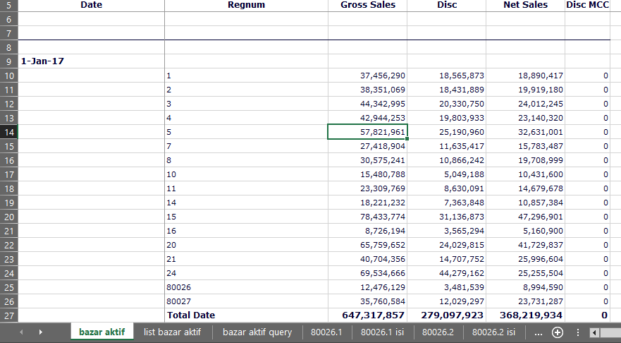

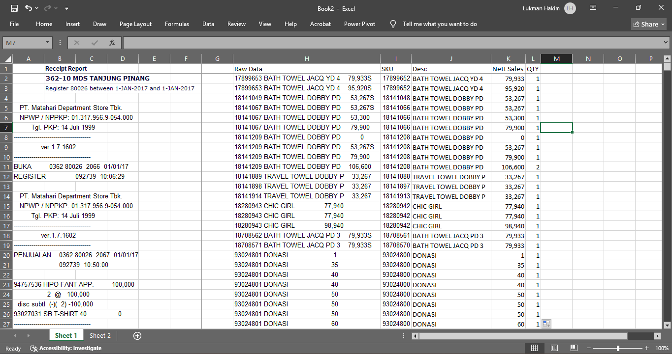
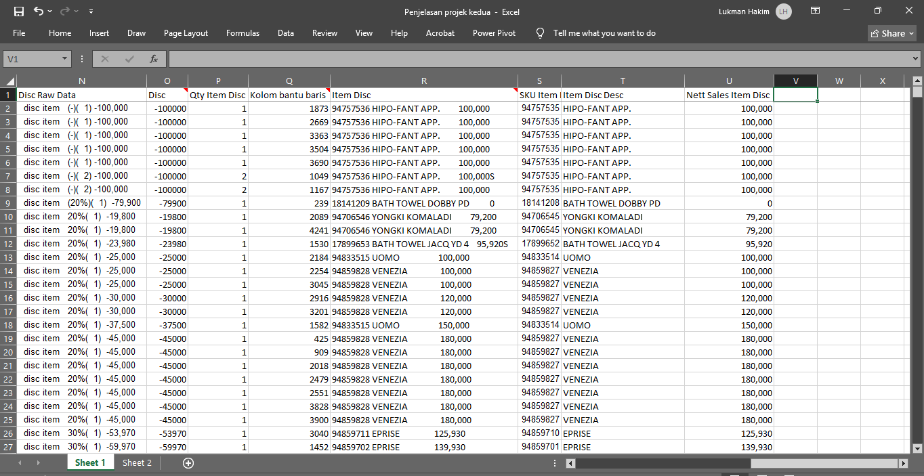

Role/Position
File Creator

Publication Link
-

Artwork/Project Description
My supervisor at the time required a sales report (Net Sales, Discount, and Gross Sales) for each brand operating within the Bazaar area. The report was intended to evaluate which brands were suitable or unsuitable for the Bazaar area, as well as to identify promotions preferred by consumers. Unfortunately, the Alphapos system (the primary reporting platform) did not provide such detailed information at that time. The data available was limited to overall totals of Gross Sales, Discount, and Net Sales only.


Pic 1. Summary Register Report
I sought alternative methods and identified what information could be processed to achieve the desired output. Eventually, I discovered that the required data could potentially be derived from the purchase receipt records.
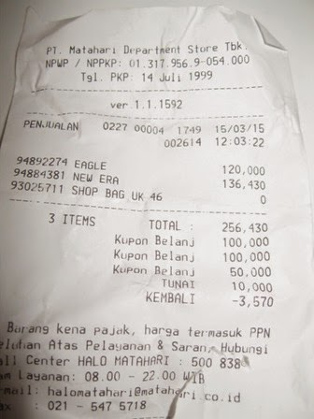
Pic 2. Example of sales receipt
Upon confirming the availability of a transaction history feature (Receipt Report) within the system, I proceeded to process the data accordingly.
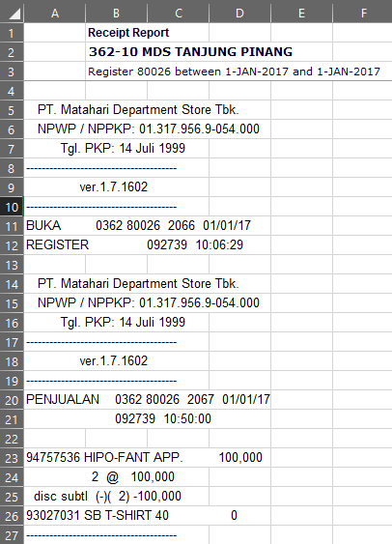
Pic 3. Receipt Report
Initially, I was able to retrieve sales data per SKU by using the search feature with primary keys 1*, 2*, and 9* (as Matahari SKUs begin with one of these three digits). However, I still required discount data in order to determine the type of promotion applied, whether for DP (Direct Purchase) or CV (Consignment) items. Upon examining the receipt structure, I observed that the discount value was consistently positioned two or three rows below the net price SKU row. And by applying Excel formulas (MATCH and INDEX), I was able to extract the required information.

Steps:
- Retrieve the Receipt Report for the desired date and bazaar machine number from Alphapos (please note that I no longer have access to the Alphapos system).
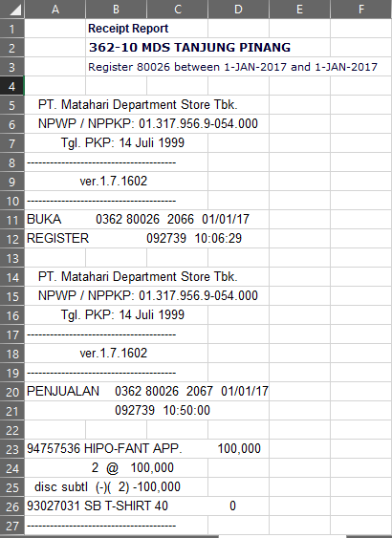
Pic 4. Receipt Report
- Paste the data into Microsoft Excel across two separate sheets.
- Sheet 1 is used for the primary data processing.
- Sheet 2 is used as a filtering workspace to locate the required data, ensuring it does not interfere with the primary sheet.
- In Sheet 2, first apply an ascending (A to Z) sort. This is intended to facilitate the retrieval of 8-digit SKU data. Subsequently, apply the filter feature using the following primary keys:
- 1* to retrieve SKUs for DP (Direct Purchase) items
- 2* to retrieve SKUs for certain CV (Consignment) items
- 9* to retrieve SKUs for certain CV (Consignment) items
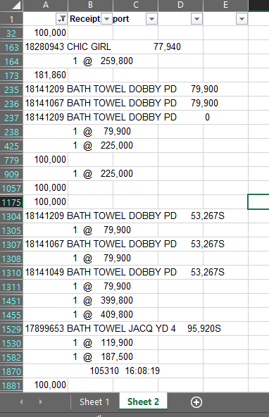  Pic 5. Filter result without prior sorting applied. | 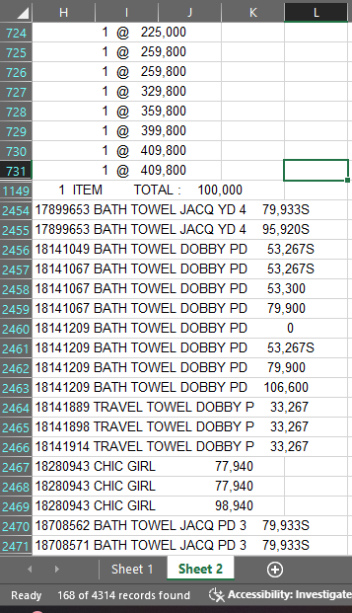  Pic 6. Filter result with prior sorting applied. The desired data will appear in a more organised format, facilitating easier extraction
Filter result with prior sorting applied. The desired data will appear in a more organised format, facilitating easier extraction.
- Each result obtained from the search in Step 3 is to be pasted into Sheet 1 in the format illustrated below.
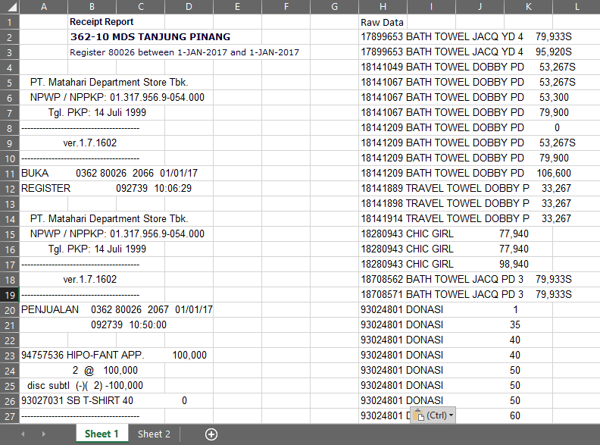
Pic 7. The pasted data results
- The data contained in column H (Raw Data) is structured as “SKU – Item Description – Net Sales”. Qty formula will subsequently be added. The formulas for each required variable are as follows:
- SKU Formula
This formula is to be applied in column I using the following expression:
=LEFT(H2,FIND(" ",H2))-1
The purpose of this formula is to extract text from the left, with the character count set to the position of the first space minus 1. The expected result is the SKU number. Example: 17899653 or 93024801.
- Item Description Formula
This formula is to be applied in column J using the following expression:
=MID(H2,FIND(" ",H2)+1,LEN(H2)-(FIND(" ",H2)+1)-(LEN(H2)-FIND("]",SUBSTITUTE(H2," ","]",LEN(H2)-LEN(SUBSTITUTE(H2," ",""))))))
The purpose of this formula is to extract the Item Description only. In simple terms, the formula operates as follows:
- Logic: A + B + C = D.
- A is SKU, B is description, C is net sales and D is total length.
- Extract B (description) by: total length (D) minus SKU (A) minus net sales (C).
- The SKU is removed using the first space, and net sales is removed using the last space (via the SUBSTITUTE trick).

The formula is explained as follows:
- Main function: MID
=MID(H2, … , … )
    - MID is used to extract a substring from cell H2.
    - It takes 3 parameters:
- Text → H2
- Start_num → starting position of extraction
- Num_chars → number of characters to extract
- Starting position: (Start_num)
FIND(" ",H2)+1
- Locate the first space in cell H2.
- Add +1 to begin extraction after the first space.
- This means: discard the SKU at the front, and begin extraction from the description.
- Number of characters (Num_chars)
LEN(H2) - (FIND(" ",H2)+1) - (LEN(H2)-FIND("]",SUBSTITUTE(...)))
This is the most complex part. The underlying logic is based on the equation A (SKU) + B (Item Desc) + C (Net Sales) = D (Full Cell). Therefore, B (Item Desc) = D (Full Cell) - A (SKU) - C (Net Sales)
a. LEN(H2)
- Total length of text in cell H2.
- Consider this as D (total).
b. (FIND(" ",H2)+1)
- Length of the SKU portion plus the first space.
- Consider this as A (SKU).
c. (LEN(H2)-FIND("]",SUBSTITUTE(...)))
- Length of the net sales portion at the end.
- Consider this as C (price).
- Last space trick
SUBSTITUTE(H2," ","]",LEN(H2)-LEN(SUBSTITUTE(H2," ","")))
    - LEN(H2)-LEN(SUBSTITUTE(H2," ","")) → counts the total number of spaces in the text.
    - SUBSTITUTE(...," ","]", space_count) → replaces the last space with ].
    - FIND("]", …) → locates the position of ] (representing the last space).
- Net Sales Formula
This formula operates according to the following logic:
- Mark the last space with “]”.
- Extract all text after “]” → this yields the net sales value.
- Remove the letter S if present.
- Convert the result to a numeric value using VALUE.

This formula is to be applied in column K using the following expression:
=VALUE(SUBSTITUTE(RIGHT(H2,LEN(H2)-FIND("]",(SUBSTITUTE(H2," ","]",LEN(H2)-LEN(SUBSTITUTE(H2," ","")))))),"S",""))
- Main function: VALUE(...)
    - Converts the text output into a numeric value.
- Bagian inti: SUBSTITUTE(...,"S","")
    - Removes the letter “S” from the result. This is necessary because a trailing “S” character appears in the Net Sales value when a discount has been applied to the item.
    - This ensures that the output contains only a clean numeric value.
- Extract the right portion: RIGHT(H2, LEN(H2)-FIND("]", ...))
    - RIGHT is used to extract a substring from the right side of cell H2.
    - The length of the substring is determined by LEN(H2)-FIND("]", ...).
    - This means: extract all characters following the ] symbol (used as a marker for the last space).
- Last space trick: SUBSTITUTE(H2," ","]",LEN(H2)-LEN(SUBSTITUTE(H2," ","")))
    - LEN(H2)-LEN(SUBSTITUTE(H2," ","")) → calculates the total number of spaces in the text.
    - SUBSTITUTE(...," ","]", space_count) → replaces the last space with ].
    - This allows us to identify the starting position of the net sales value (after the last space).
- The final result will appear as follows:
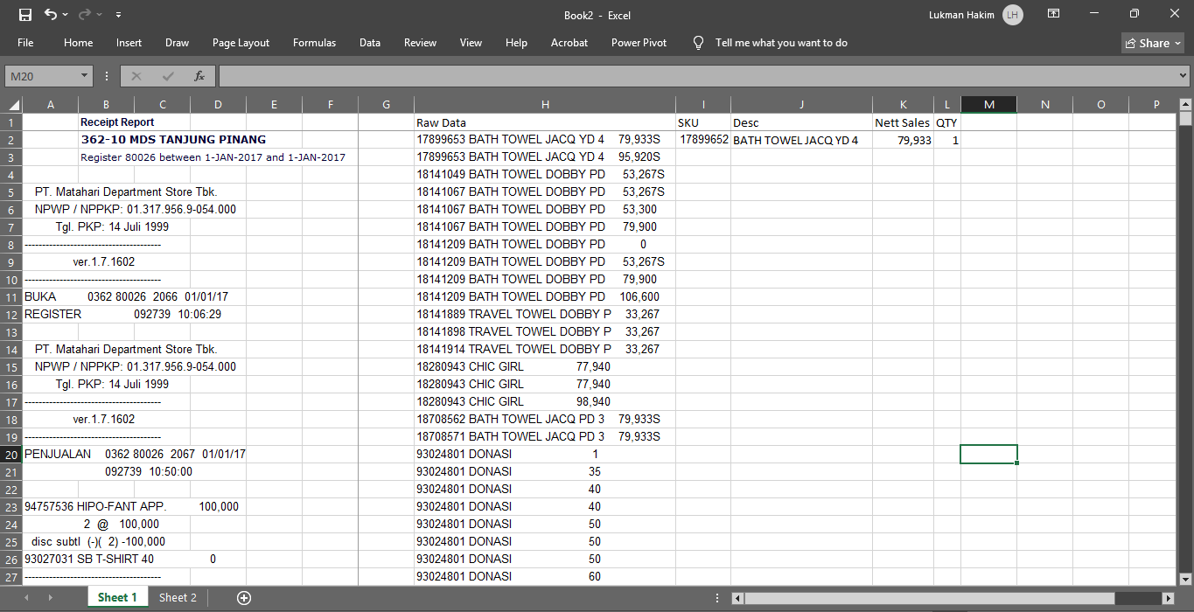
Pic 8. Final result with all formulas
- Copy and paste the formulas down to the last row of raw data. The formulas for Net Sales and Qty Net Sales are now complete.

Pic 9. Copy and paste the formula into all rows of data
- To retrieve discount information, return to Sheet 2 and access the filter menu. Type “disc” in the search column and press Enter.
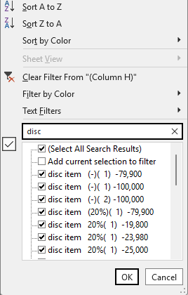
Pic 10. Filter to get discount data
- Copy all “disc item” and “disc subtl” data, then paste it into Sheet 1. In this example, the data is pasted into column N.
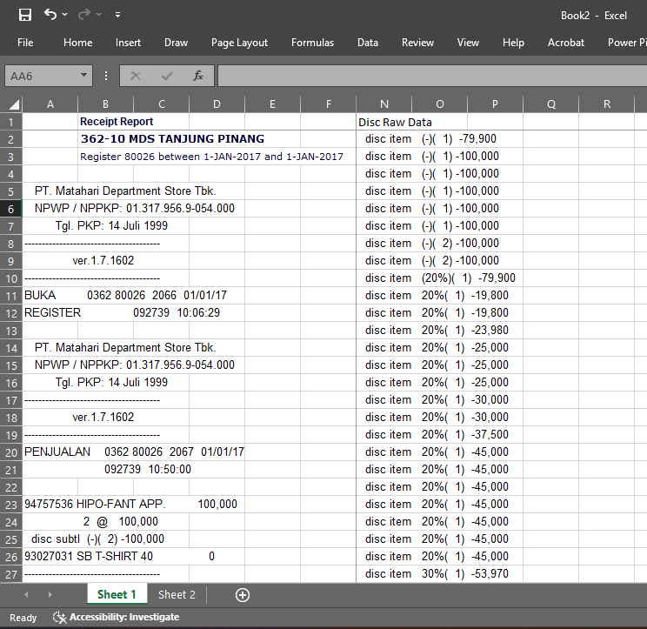
Pic 11. The result of pasting discount data into sheet 1.
- We will then add the following columns:
- Disc
- Help Collumn
- Item Disc Desc
  - SKU Item Disc
  - Item Disc Desc
  - Nett Sales Item Disc
- Qty Item Disc
- The respective formulas are as follows:
- Disc
The discount appear in two distinct formats, namely:
- disc item (-)( 1) -100,000
- disc item 20%( 1) -19,800
What is required from both formats is to extract the numeric discount value located beside the negative sign at the end. Ideally, a MID formula beginning at the negative character “-” would be used; however, this approach only works for format (b) and produces an error for format (a). Since the desired output must be numeric, the formula I developed is as follows:
=IFERROR(NUMBERVALUE(MID(N2,FIND("-",N2),LEN(N2))),(MID(N2,FIND("-",N2,FIND("-",N2)+1),LEN(N2))))*1
  - Main function: IFERROR(...)
- Purpose: if the first attempt returns an error, the second attempt is executed.
  - First attempt
NUMBERVALUE(MID(N2,FIND("-",N2),LEN(N2)))
- This is used to extract the discount value in format (b): “disc item 20%( 1) -19,800”
- FIND("-",N2) → locates the position of the first minus sign (-) in the text of cell N2.
- MID(N2,FIND("-",N2),LEN(N2)) → extracts the substring starting from the first minus sign to the end of the text.
- NUMBERVALUE(...) → converts the substring into a numeric value.
  - Second attempt (fallback)
NUMBERVALUE(MID(N2,FIND("-",N2,FIND("-",N2)+1),LEN(N2)))
- This is used to extract the discount value in format (a): “disc item (-)( 1) -100,000”
- FIND("-",N2,FIND("-",N2)+1) → locates the second minus sign (beginning the search after the first minus).
- MID(N2,...,LEN(N2)) → extracts the substring starting from the second minus sign to the end of the text.
- NUMBERVALUE(...) → converts the substring into a numeric value.
- Therefore, if two minus signs are present, extraction begins at the second minus sign.
- Qty Item Disc
This formula is intended to display the quantity of discounted items, as follows:
=--MID(N2,FIND("( ",N2)+1,FIND(")",N2,FIND("( ",N2)+1)-(FIND("( ",N2)+1))
This formula operates according to the following logic:
- Locate the opening parenthesis followed by a space “( ” and the closing parenthesis “)” within the text of cell N2.
- Extract the substring between them (the number enclosed in parentheses).
- Convert the substring result into a numeric value using the double unary operator (--).

Formula breakdown:
- Bagian MID(...)
MID(N2, FIND("( ",N2)+1, FIND(")",N2,FIND("( ",N2)+1) - (FIND("( ",N2)+1))
- Text → N2 (cell content).
- Start_num → FIND("( ",N2)+1
  - Locate the position of the string "( " (opening parenthesis followed by a space).
  - Add +1 to begin extraction after that symbol.
- Num_chars → FIND(")",N2,FIND("( ",N2)+1) - (FIND("( ",N2)+1)
  - Locate the position of the closing parenthesis ")" after the opening parenthesis.
  - Subtract the starting position from this value → the result is the length of the substring within the parentheses.
This MID function therefore extracts the number enclosed within the parentheses.
- The -- Section
The -- operator is an Excel technique for converting a text-formatted number into a numeric value. The final output is therefore a pure numeric value, not text.
- Help Collumn
This column is intended to provide precise row location information for each discount entry. It contains two formulas, as follows:
- =MATCH(N2,A:A,0)
This formula applies exclusively to cell 2, as no complex processing is required at that cell. The formula searches for the value in N2 within column A and returns its relative position.

- =IF(MATCH(N3,A:A,0)=MINIFS($P$2:P2,$N$2:N2,N3),MATCH(N3,INDIRECT("A"&P2+1&":A1000000"),0)+P2,MATCH(N3,A:A,0))
This formula applies from the second row onwards. It operates according to the following logic:
- Check whether the first MATCH result corresponds to the minimum qualifying row in column N (Disc Raw Data), in order to prevent duplicate row references.
- If the condition is true → the next occurrence of N3 must be located (using the INDIRECT + MATCH combination). Since the row value is always positioned above cell N2, the calculation is performed within the range A("Row Value") to A1000000. The result is then added to the value of P2 itself, as when the condition is true, the search is for the next occurrence of N3 after row P2.
- If the condition is false → simply retrieve the first MATCH result, as the calculation begins from the start of the entire column A.
- Item Disc Desc
The primary purpose of this column is to display the discounted item. For reference, the Discount display format appears in two variants: single-tier discount and double-tier discount (also referred to as a double discount).
Format 1 (Single-Tier Discount) | Tampilan 2 (Disc 2 tingkat or Double Disc)
94757536 HIPO-FANT APP. 100,000  2 @ 100,000  disc item (-)( 1) -100,000 | 94859711 EPRISE 125,930  1 @ 359,800  disc item 50%( 1) -179,900  disc item 30%( 1) -53,970
Based on the above, it can be observed that the SKU of the discounted item will be located 2 rows (for a single-tier discount) or 3 rows (for a double-tier discount) above the discount row. The formula I developed for this purpose is as follows:
=IF(OR(LEFT(INDIRECT("a"&P2-2),1)="1",LEFT(INDIRECT("a"&P2-2),1)="2",LEFT(INDIRECT("a"&P2-2),1)="9"),INDIRECT("a"&P2-2),INDIRECT("a"&P2-3))
- Main function: IF and Logical Test

IF(OR(
LEFT(INDIRECT("A"&P2-2),1)="1",
LEFT(INDIRECT("A"&P2-2),1)="2",
LEFT(INDIRECT("A"&P2-2),1)="9"
))

This formula verifies whether the result of the INDIRECT("A"&P2-2) process (explained below) is a valid SKU, confirmed by checking whether the first character from the left equals 1, 2, or 9.
- Value_if_true
INDIRECT("A"&P2-2)
If the condition is true, retrieve the cell content in column A at row (P2-2).
- Value_if_false
INDIRECT("A"&P2-3)
If the condition is false, retrieve the cell content in column A at row (P2-3).
  - SKU Item Disc
This follows the same process as the SKU formula in column I, as follows:
=LEFT(R2,FIND(" ",R2))-1
This formula is intended to extract the SKU characters. It extracts characters up to the first space encountered and subtracts 1, ensuring the result contains only the SKU value.
  - Item Disc Desc
This follows the same process as the Description formula in column J, as follows:
=MID(R2,FIND(" ",R2)+1,LEN(R2)-(FIND(" ",R2)+1)-(LEN(R2)-FIND("]",SUBSTITUTE(R2," ","]",LEN(R2)-LEN(SUBSTITUTE(R2," ",""))))))
The purpose of this formula is to extract the Item Description only. The formula is explained as follows:
- Main function: MID
=MID(H2, … , … )
    - The MID function extracts a substring from cell H2 using three parameters: source text, starting position, and number of characters.
- Starting position: (Start_num)
FIND(" ",H2)+1
- Locate the first space in cell H2.
- Add +1 to begin extraction after the first space.
- This means: discard the SKU at the front, and begin extraction from the description.
- Number of characters (Num_chars)
LEN(H2) - (FIND(" ",H2)+1) - (LEN(H2)-FIND("]",SUBSTITUTE(...)))
This is the most complex part. The underlying logic is based on the equation A (SKU) + B (Item Desc) + C (Net Sales) = D (Full Cell). Therefore, B (Item Desc) = D (Full Cell) - A (SKU) - C (Net Sales)
a. LEN(H2)
- Total length of text in cell H2.
- Consider this as D (total).
b. (FIND(" ",H2)+1)
- Length of the SKU portion plus the first space.
- Consider this as A (SKU).
c. (LEN(H2)-FIND("]",SUBSTITUTE(...)))
- Length of the net sales portion at the end.
- Consider this as C (price).
- Last space trick
SUBSTITUTE(H2," ","]",LEN(H2)-LEN(SUBSTITUTE(H2," ","")))
    - LEN(H2)-LEN(SUBSTITUTE(H2," ","")) → counts the total number of spaces in the text.
    - SUBSTITUTE(...," ","]", space_count) → replaces the last space with ].
    - FIND("]", …) → locates the position of ] (representing the last space).
In simple terms, this formula operates as follows:
- Logic: A + B + C = D.
- Extract B (description) by: total length (D) minus SKU (A) minus net sales (C).
- The SKU is removed using the first space, and net sales is removed using the last space (via the SUBSTITUTE trick).
  - Nett Sales Item Disc
This follows the same formula as the Net Sales formula in column K, as follows:
=VALUE(SUBSTITUTE(RIGHT(R2,LEN(R2)-FIND("]",(SUBSTITUTE(R2," ","]",LEN(R2)-LEN(SUBSTITUTE(R2," ","")))))),"S",""))
- Main function: VALUE(...)
    - Converts the text output into a numeric value.
- Bagian inti: SUBSTITUTE(...,"S","")
    - Removes the letter “S” from the result. This is necessary because a trailing “S” character appears in the Net Sales value when a discount has been applied to the item.
    - This ensures that the output contains only a clean numeric value.
- Extract the right portion: RIGHT(H2, LEN(H2)-FIND("]", ...))
    - RIGHT is used to extract a substring from the right side of cell H2.
    - The length of the substring is determined by LEN(H2)-FIND("]", ...).
    - This means: extract all characters following the ] symbol (used as a marker for the last space).
- Last space trick: SUBSTITUTE(H2," ","]",LEN(H2)-LEN(SUBSTITUTE(H2," ","")))
    - LEN(H2)-LEN(SUBSTITUTE(H2," ","")) → calculates the total number of spaces in the text.
    - SUBSTITUTE(...," ","]", space_count) → replaces the last space with ].
    - FIND("]", ...) → locates the position of ].
    - This allows us to identify the starting position of the net sales value (after the last space).
    - Net Sales Formula
Gampangnya This formula operates according to the following logic:
- Mark the last space with ].
- Extract all text after ] → this yields the net sales value.
- Remove the letter S if present.
- Convert the result to a numeric value using VALUE.
- Upon completing Step 11, copy the formulas down to obtain the following result:

Pic 12. Complete formula for each row
- Finally, please check by totaling net sales, quantity net sales, and discount, then compare it with the Summary Register Report obtained from the Alphapos menu.
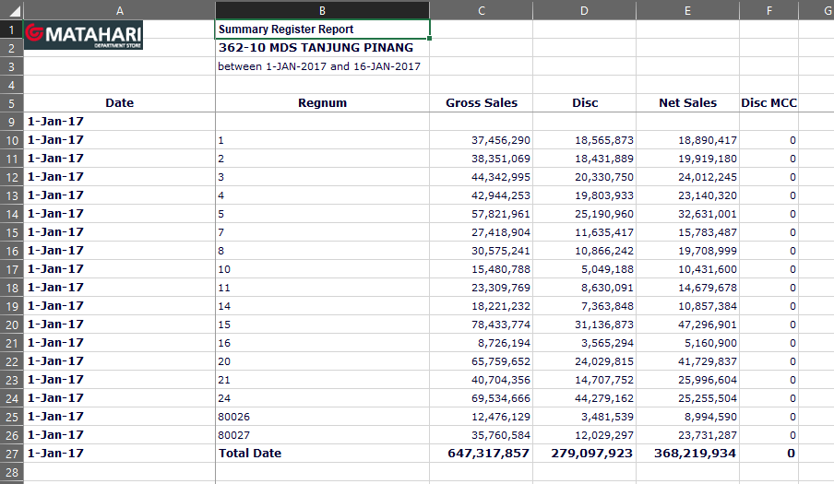
Pic 13. Compare the numbers with Summary Register Report
- As verification, in Step 13, refer to Register Number 80026 and compare it against our calculated results.
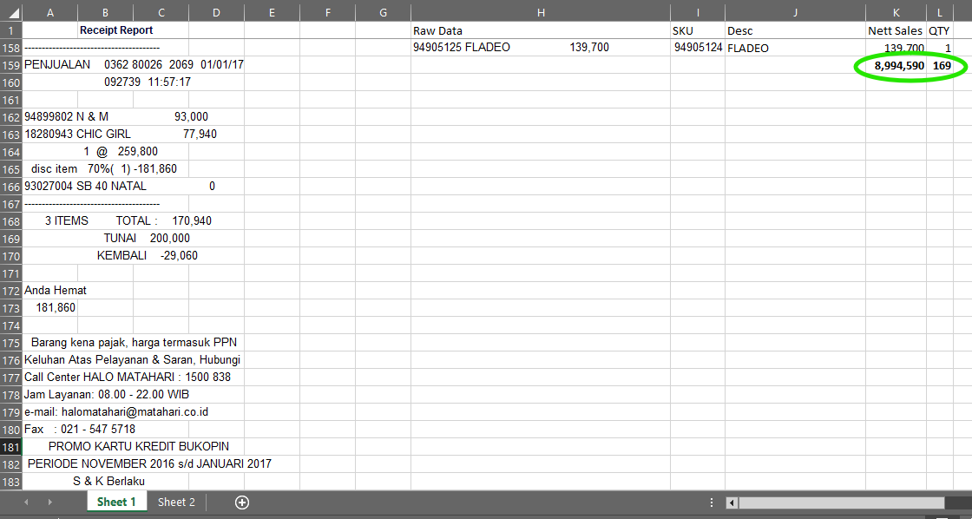  Pic 14. Total net sales from formula calculation | 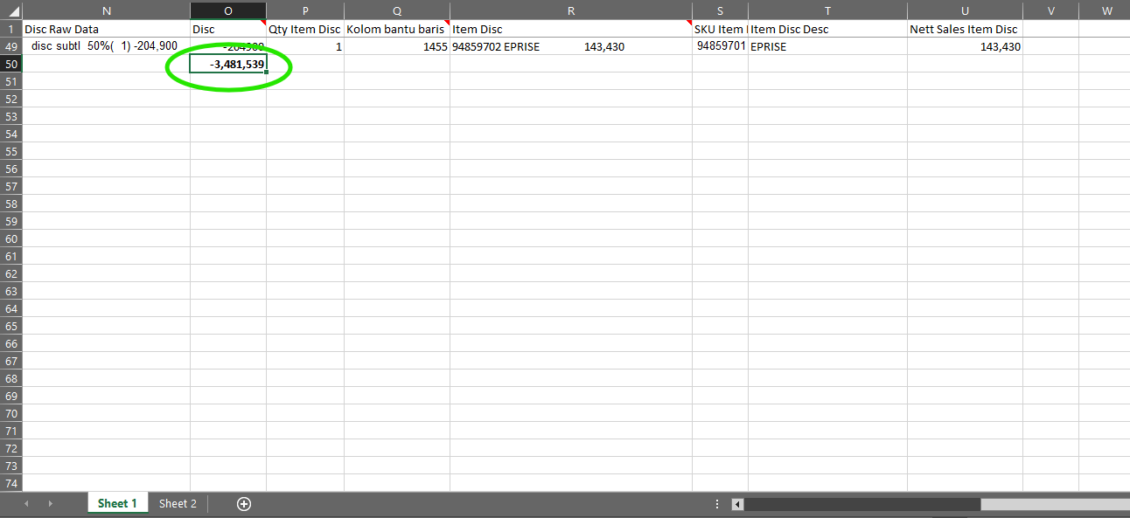  Pic 15. Total disc from formula calculation

